# Guidance on Position Estimation Setup

Indoor positioning is an important part in our project. The autonomous flight of drones heavily relies on accurate local frame coordinate.This article is a guidance on how to set up the markers and the camera to get the best position estimation performance.

1. Setup the markers.

First of all, we need to stick some markers on the wall and measure the distance between these markers.

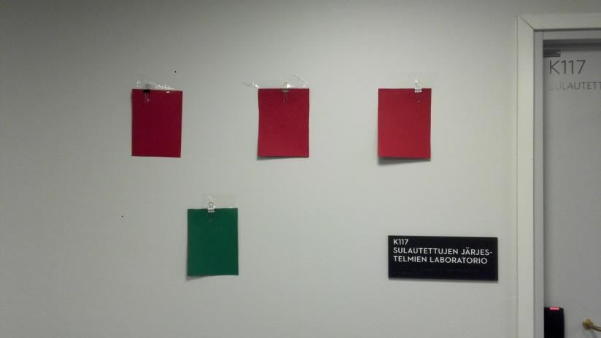

Fig.1. Marker setup in our experiment.

The four stickers correspond to the four point L, M, R, and S. From the left to the right, The three red stickers are point L, R, S. And the green sticker is point M. There is a picture in the essay that shows the relationship clearly.

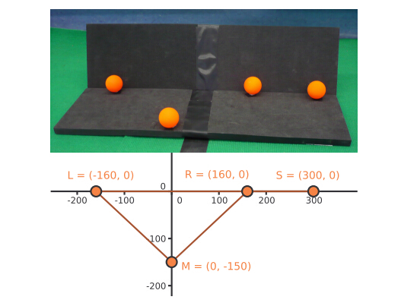

Fig. 2. The marker reference frame mentioned in the paper.

The distance between L and R, M and O (O is the middle point of L and R) needs to be measured. And then change the corresponding place in the program. The names of the variable are distanceOfLr and distanceOfMo.

The default value of LR is 50cm,MO is 34cm.You can set the two arguments in the program.

The second step is to open the pixymon. In pixymon, you can reset the signature. Signature is the color of marker. In pixymon, you can set single color or mixed color as the color of the marker. When the program does not output the right position, we can reset the signature. And remember to observe the pixymon program with default mode.

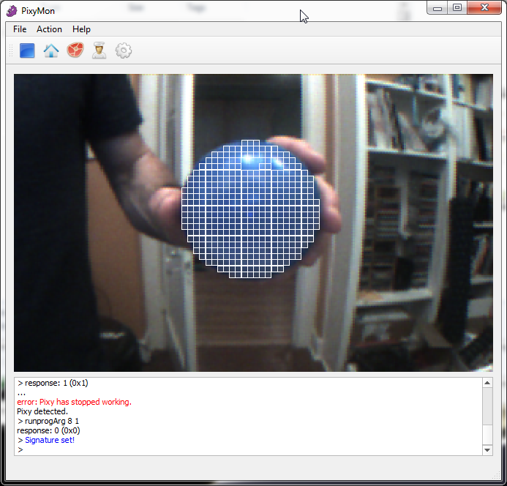

Fig. 3. Set signature in pixymon

Because of the change of external illumination, It’s recommended to manually set the signature before the experiment, which increases the stability of the marker detection.

When there are only very small changes in the pixel, the result is possible to change in a great range finally. As a result, the more accurate pixel we get, the better the result is.

1. Set the arguments of the position estimation program.

There are two optional arguments for the pixy_node currently.

|  |  |
| --- | --- |
| -i | Invert the camera image (upside down). |
| -D | Disable the pan tilt function. |
| -h | Show the help. |
| -d | Followed by a integer. Set the distance between lens and the image sensor. It is a relative value,default is 240. |
| -l | Followed by a integer(cm). Set the distance of LR. |
| -m | Followed by a integer(cm). Set the distance of MO. |

1. Run the program.

The program relies on ROS. After setting up the ROS environment, you can use rosrun or roslaunch to run the program.

Example:

rosrun pixy_node pixy_node -i -d 250 -l 50 -m 20

1. Trouble shooting.

This program is not stable now. It’s possible you can’t get a stable reading.There are several advices.

|  |  |
| --- | --- |
|  |  |